**Activity – Informatica**  
  
Maximum Car Prices

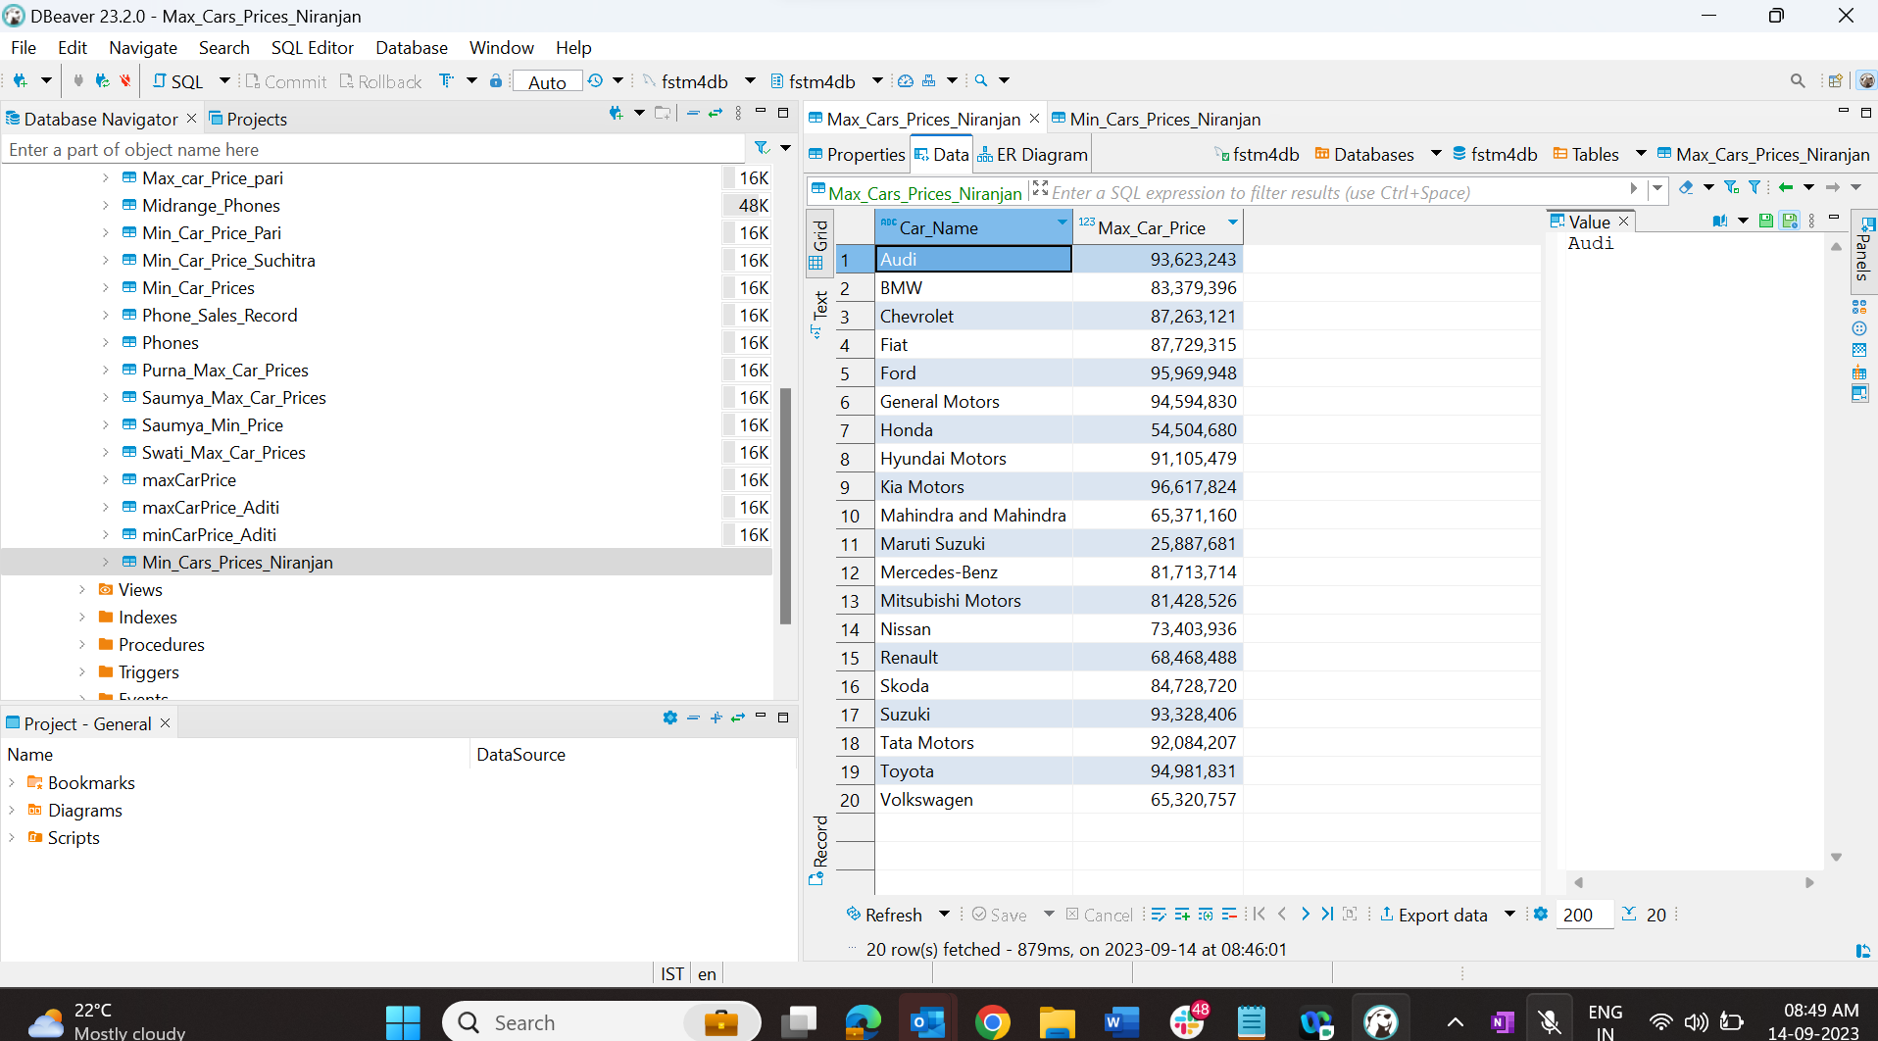

Minimum Car Prices

